Decimal Numbers

Look at this code:
distance = float(input("Enter kilometres: "))
travel_minutes = float(input("Enter travel minutes (not 0): "))
speed = distance / travel_minutes
print("Kilometres per minute:", speed)

What do you think this code will display?
Click or tap here to enter text.

Run the code. Compare the result with your prediction:
Click or tap here to enter text.

Let’s investigate! Answer the questions below:
- If you enter 7.5, which value is stored in distance?
Click or tap here to enter text.

- Why does this program use float() instead of int() for 7.5?
Click or tap here to enter text.

- If you enter 9 and 3, what complete line appears on screen?
Click or tap here to enter text.

- For inputs 7.5 and 3, why is the result 2.5 rather than 2?
Click or tap here to enter text.

Decimal Numbers

Look at this code:
distance = float(input("Enter kilometres: "))
travel_minutes = float(input("Enter travel minutes (not 0): "))
speed = distance / travel_minutes
print("Kilometres per minute:", speed)

Use the code above to help you. After completing each challenge below, run your program to test that it works correctly. Save each completed challenge program in a new file.

Programming Challenges

Challenge 1
Store [distance] / 2 in a variable called [halfway_distance]. Display [halfway_distance] before [speed]. Test 9 kilometres and 3 minutes; the halfway distance should be 4.5.
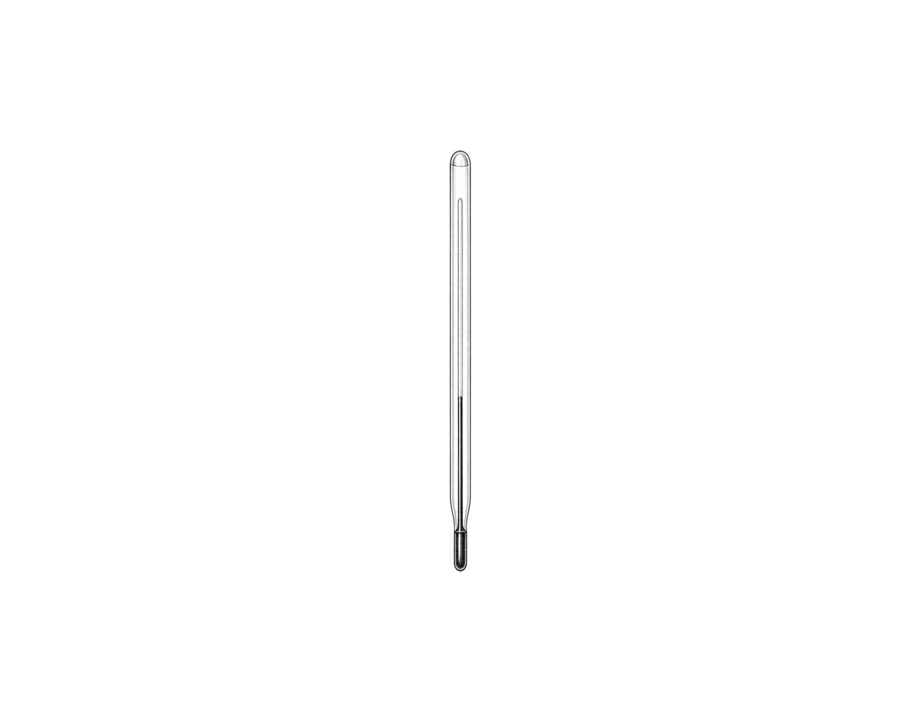

Challenge 2
Add a third decimal input called rest_minutes. Display total_minutes as travel minutes plus rest minutes. For 12.5 and 2.5, the total must be 15.0.

Challenge 3
Create a floor-area calculator. Ask for decimal length and width, multiply them, and display a labelled area. Test 4.5 by 2: the area should be 9.0.

Decimal Numbers

Fix the code!

This code has errors! Look closely at the code to find the problems:

distance = float(input("Enter kilometres: "))
minutes = float(input("Enter minutes: ")
speed = distance / minute
print("Kilometres per minute:", speed)

Rewrite the whole program in the box below with fixes to the errors.
Click or tap here to enter text.

After you are confident that you fixed all the errors, copy the code from the box and run it.

Did it work correctly on your first try? Did you find all the errors?
Click or tap here to enter text.

